实验八、数组及字符串对象

1. 完成倒数10秒的倒计时功
2. 完成元旦的倒计时功能
3. 完成随机点名程序
4. 完成电子邮箱的验证
5. 完成简单的表单验证，如图

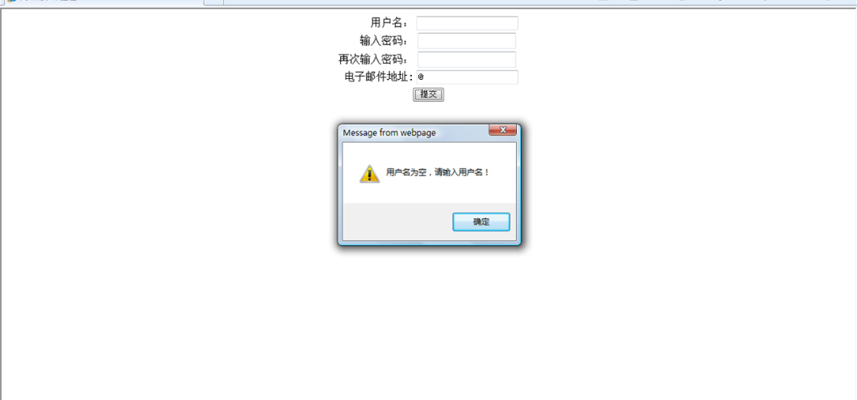

1. 选做：教材P66页省份城市三级联动的实践
2. 截图：

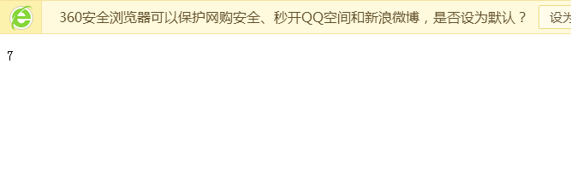

1. 截图：

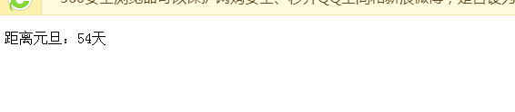

3.截图：

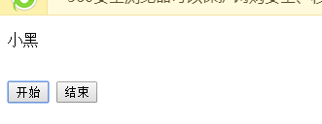

1. 截图：

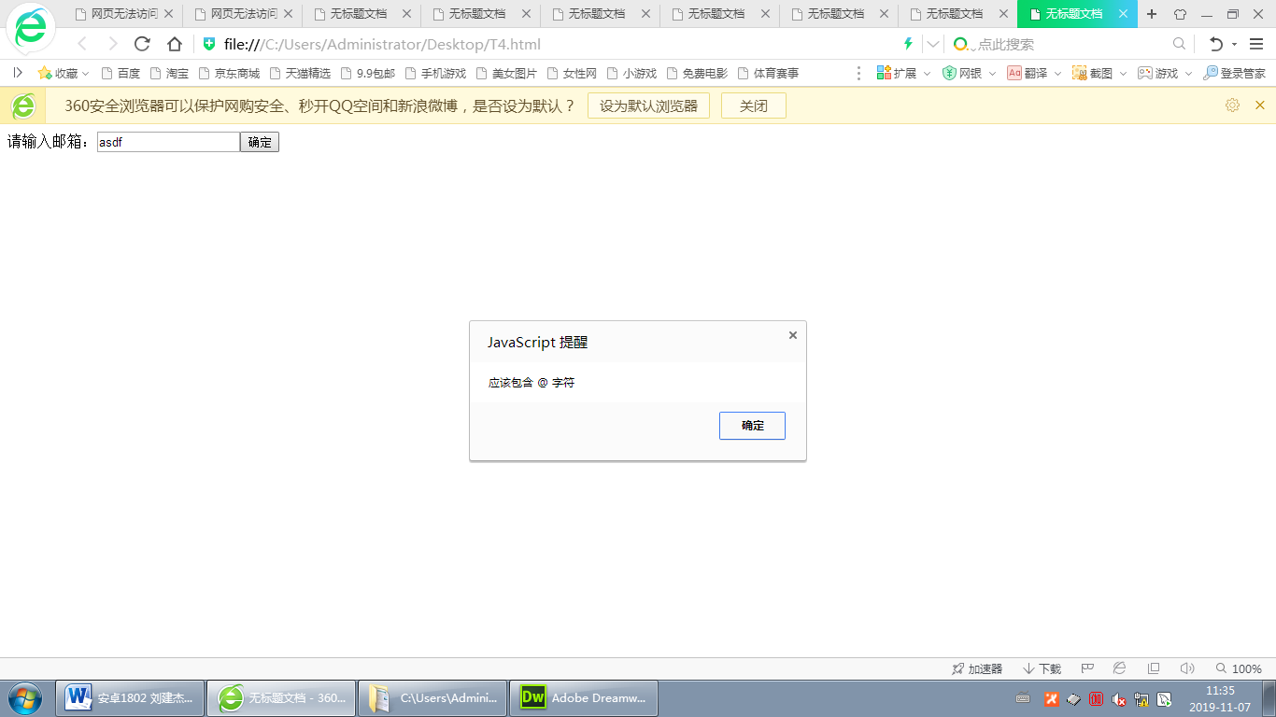

5.截图：

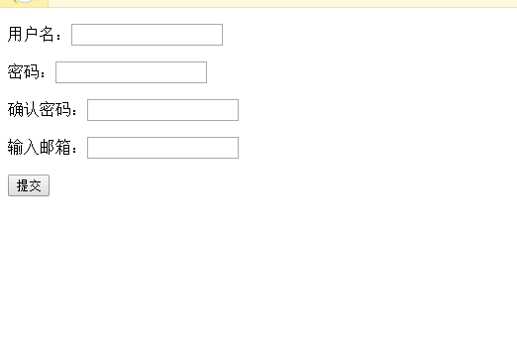

6.截图：

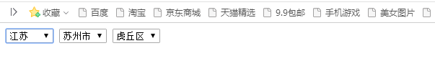

代码：

1.

<!DOCTYPE html PUBLIC "-//W3C//DTD XHTML 1.0 Transitional//EN" "http://www.w3.org/TR/xhtml1/DTD/xhtml1-transitional.dtd">

<html xmlns="http://www.w3.org/1999/xhtml">

<head>

<meta http-equiv="Content-Type" content="text/html; charset=utf-8" />

<title>无标题文档</title>

</head>

<body>

<p id="show"></p>

<script>

// 1种

//var val = 10;

//function out(){

// document.getElementById("show").innerHTML = val;

// if(val > 0){

// val--;

// setTimeout("out();",1000);

// }

//}

//out();

//2 种方法

var num = 10;

var ins;

function prints(){

document.getElementById("show").innerHTML = num;

num > 0 ? num-- : clearInterval(ins);

}

ins = setInterval("prints();",1000);

</script>

</body>

</html>

2.

<!doctype html>

<html>

<head>

<meta charset="utf-8">

<title>无标题文档</title>

</head>

<body>

<p id="show"></p>

<script>

function test(){

var yundate = new Date("1/1/2020");

var nowdate = new Date();

var dissecond = yundate.getTime() - nowdate.getTime();

var days = Math.floor(dissecond / (1000 \* 60 \* 60 \* 24));

if(days > 0){

document.getElementById("show").innerHTML = "距离元旦："+days+"天";

}else{

document.getElementById("show").innerHTML = "元旦已经过了";

}

}

test();

</script>

</body>

</html>

3.

<!doctype html>

<html>

<head>

<meta charset="utf-8">

<title>无标题文档</title>

</head>

<body>

<p id="show"></p>

<br/>

<input type="button" value="开始" onclick="start();"/>

<input type="button" value="结束" onclick="end();"/>

<script>

// array

var ar = ["小明","小花","小绿","小蓝","小黄","小红","小青","小白","小黑","小一","小二","小三","小四","小五","小六","小七","小八","小九","小十","大一","大二","大三"];

var ins;

function fuzhi(){

var index = Math.round(Math.random() \* (ar.length - 1));//随机数

document.getElementById("show").innerHTML = ar[index]

}

function start(){

ins = setInterval("fuzhi();",60);

}

function end(){

clearInterval(ins);

}

</script>

</body>

</html>

4.

<!doctype html>

<html>

<head>

<meta charset="utf-8">

<title>无标题文档</title>

</head>

<body>

请输入邮箱：<input id="inputEmal" type="text" /><input type="button" value="确定" onclick="check();"/>

<script>

function check(){

var emstr = document.getElementById("inputEmal").value;

if(emstr.trim() == ""){

alert("不能为空");

}else if(emstr.indexOf("@") == -1){

alert("应该包含 @ 字符");

}else if(emstr.indexOf(".") == -1){

alert("应该包含 . 字符");

}

}

</script>

</body>

</html>

5.

<!doctype html>

<html>

<head>

<meta charset="utf-8">

<title>无标题文档</title>

</head>

<body>

<form>

<p>用户名：<input type="text" id = "user"></p>

<p>密码：<input type="text" id = "pwd"></p>

<p>确认密码：<input type="text" id = "pwd2"></p>

<p>输入邮箱：<input type="text" id = "email"></p>

<p><input type= "button" onclick="check();" value="提交"> </p>

</form>

<script>

function check(){

var user = document.getElementById("user").value;

var pwd = document.getElementById("pwd2").value;

var pwd2 = document.getElementById("pwd2").value;

var emstr = document.getElementById("email").value;

if(user == ""){

alert("用户名不能为空");

}else if(pwd == ""){

alert("密码不能为空");

}else if(pwd2 != pwd){

alert("两次密码不一致");

}

else if(emstr.trim() == ""){

alert("邮箱不能为空");

}else if(emstr.indexOf("@") == -1){

alert("应该包含 @ 字符");

}else if(emstr.indexOf(".") == -1){

alert("应该包含 . 字符");

}

}

</script>

</body>

</html>

6.

<!doctype html>

<html>

<head>

<meta charset="utf-8">

<title>无标题文档</title>

</head>

<body>

<select id="province">

<option value="-1">请选择</option>

</select>

<select id="city">

</select>

<select id="country">

</select>

<script>

//省份

var provinceArr=['上海','江苏','河北'];

//城市

var cityArr=[

['上海市'],

['苏州市','南京市','扬州市'],

['石家庄','秦皇岛','张家口']

];

//区域

var countryArr=[

[

['黄浦区','静安区','长宁区','浦东区']],

[

['虎丘区','吴中区','相城区','姑苏区','吴江区'],

['玄武区','秦淮区','建邺区','鼓楼区','浦口区'],

['刊江区','广陵区','江都区']],

[

['长安区','桥西区','新华区','井矿区'],

['海港区','山海关区','北戴河区','抚宁区'],

['桥东区','桥西区','宣化区','下花园区']

]

];

function createOption(obj, data){

for(var i in data){

var op = new Option(data[i],i);

obj.options.add(op);

}

}

var provar = document.getElementById("province");

var cityvar = document.getElementById("city");

var countryvar = document.getElementById("country");

createOption(provar,provinceArr);

provar.onchange = function(){

cityvar.options.length = 0;

createOption(cityvar,cityArr[provar.value]);

if(provar.value >= 0){

cityvar.onchange();

}else{

countryvar.options.length = 0;

}

}

cityvar.onchange = function(){

countryvar.options.length = 0;

createOption(countryvar,countryArr[provar.value][cityvar.value]);

}

</script>

</body>

</html>